In today’s scenario, one has need to travel more and more places in this world and even with in the same country. Then we may or may not have a knowledge of those new places to where we are going, then the first thing that we will do is measuring the distance from the current place to destination. Here we go that the use of our application works.

The only thing that one need to do to get the distance with in no time is just entering your login credentials and then go ahead to enter the city name for which you want to know the distance.

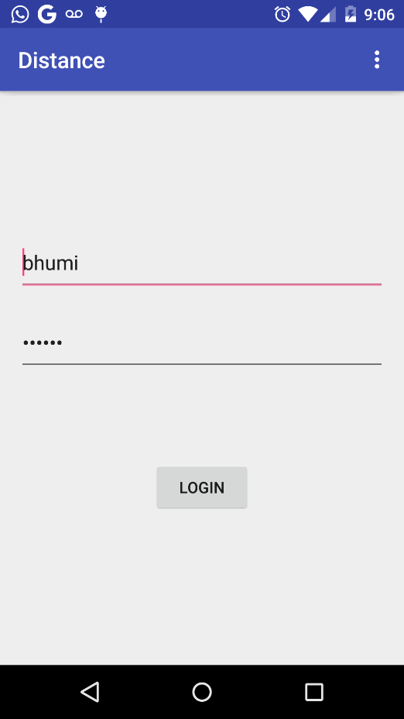

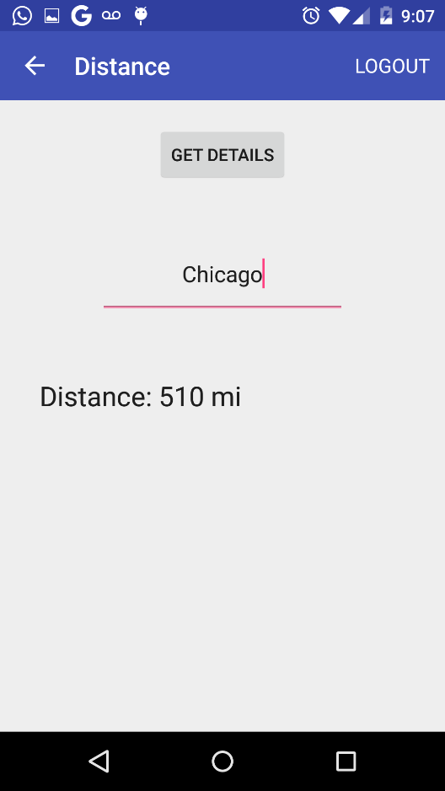

Once we get login in to the app , just we need to enter only the destination place .

Within no time we will get the exact distance from current city to the place we wish to know the distance.